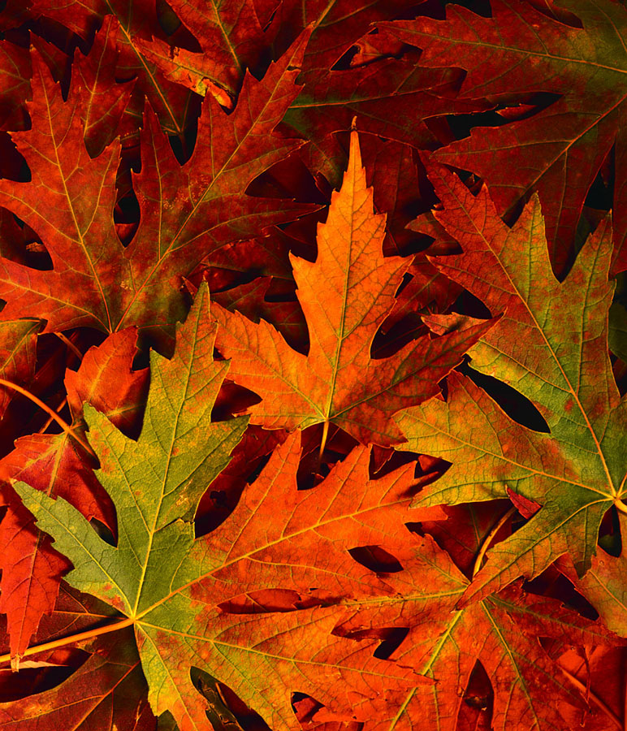
Thanksgiving from Aurora

Vegan Maple Butternut Soup $9.99/qt.
Tomato Fennel Lobster Bisque $13.99/qt.

Apple, Onion & Cheddar Tarts $32/dz.
Maine Crabcakes with Lemon-Chive Aioli $36/dz.
Baked Brie with Fig Rosemary Jam $19.99/ea.
Artisanal Fall Cheese Platter with Fig Cake, Spiced Nuts & Fruits $150/$95
Goat Cheese Torta with Sun-dried Tomatoes & Pesto $18.99/ea.
Curried Cheddar & Goat Cheese Torta with Major Grey’s Chutney $18.99/ea.
Housemade Duck Liver or Country Pâté With Brandied Cherries $19.99/lb.

Citrus Butter & Herb Roasted Turkey Breast $17.95/lb.
- Legs, Wings & thighs $9.95/lb.
Turkey Roulade with Mom’s Stuffing & Pancetta $17.95/lb.
Cornbread & Fennel Sausage Stuffing $9.95/lb.
Marika’s Mom’s Stuffing with Apricots & Pistachios $9.95/lb.
Grilled Swordfish Loin Steaks
with Charred Red Onions & Smoked Tomato-Caper Aioli $15.95/ea.
Local Chantenay Carrots with Dill & Pink Peppercorns $9.95/lb.
Maple Horseradish Brussels Sprouts $9.95/lb.
Roasted Broccolini with Toasted Buttered Breadcrumbs $9.95/LB.
Sherry creamed Cippollini Onions $9.95/lb.
Honey Roasted Delicata Squash Crescents $9.95/lb.
Roasted Local Beets with Fresh Ginger $9.95/lb.
Buttermilk & Leek Mashed Potatoes $8.95/lb.
Cider Roasted Local Fingerling Potatoes $8.95/lb.
Potato Gratin with Aged Gruyere $7.95/lb.
Vanilla Scented Sweet Potato Mash $8.95/lb.
Individual Corn Puddings $4.95/ea.
Individual Butternut Squash Tarts $8.95/4”
Brown Butter & Parsley Gravy $12.99/qt.
Cranberry Chutney $7.99/pt.

Pumpkin Bread Pudding with Caramel Sauce $17.99/ea.
Pumpkin Pie $19.99 Apple Pie $19.99 Dutch Apple Pie $19.99
Cherry Pie $19.99 Blueberry Pie $19.99 Triberry Pie $19.99
Bourbon Pecan Pie $21.99
Chocolate Cream Pie $21.99/ea.

GF 8” chocolate Truffle Torte $32.99/ea.
Pumpkin Roulade with Nutmeg Whipped Cream $32.99/ea.
8” Cranberry Curd Meringue Tart $32.99/ea.
9” Normandy Apple Tart $34.99

Cornbread $2.99/lb. Buttermilk Biscuits $14.99/dz. Popovers $2.75/ea.
Beautiful Seasonal Cookies

The Complete Thanksgiving Dinner for 2

- All packaged and ready to reheat & serve

Herb Roasted Turkey Breast
Choice of Stuffing
Buttermilk & Leek Mashed Potatoes
Chantenay Carrots
Brussels Sprouts or Broccolini
Squash or Beets
Cranberry Chutney
Gravy
2 Biscuits
Pumpkin Pie for 2

$79.99

Aurora Provisions
64 Pine Street Portland, Maine
207.871.9060
www.auroraprovisions.com
facebook: Aurora Provisions

